**Brief Description of the three Algorithms**

psAlgo

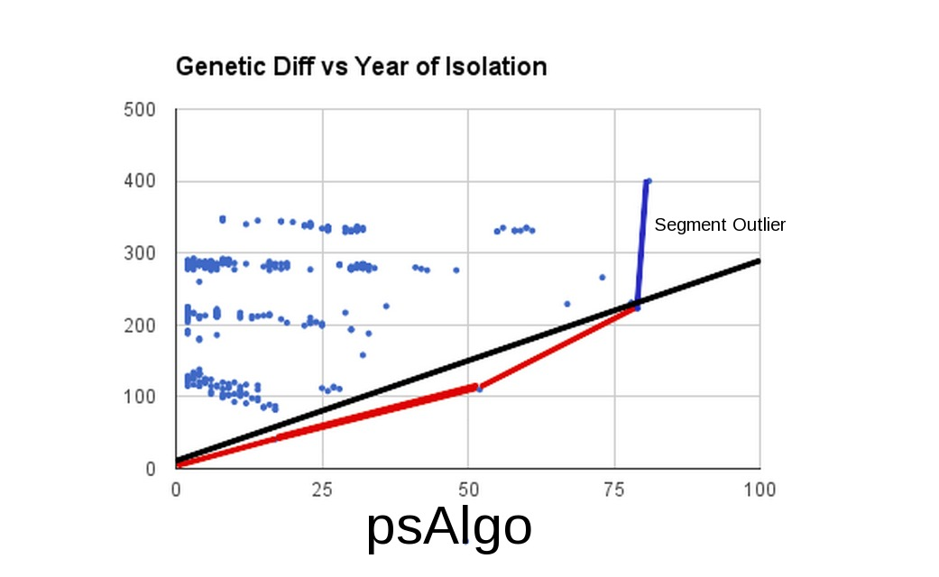

The psAlgo algorithm computes the point with the lowest possible slope from the origin. After this, psAlgo recalculates the remainder of the points in reference to the aforementioned point. psAlgo does this repeatedly until the rightmost point is reached. After this, the slopes are averaged, with a check for extremely high slopes, which are not included if the slope is 5 standard deviations from the average, as there are no statistically relevant points beyond that according to Chebyshev's Theorem. In this case, the red slopes would be averaged while the blue slope would be discarded. The averaging of the slopes yields the black line.

psAlgo2

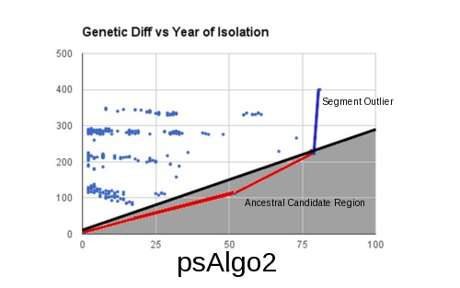

psAlgo2 uses psAlgo for estimated mutation rate (the black line). Then, psAlgo2 finds any point on or below the black line (Ancestral Candidate Region) and averages the slopes from the origin to any point lying in this region.

psAlgo3

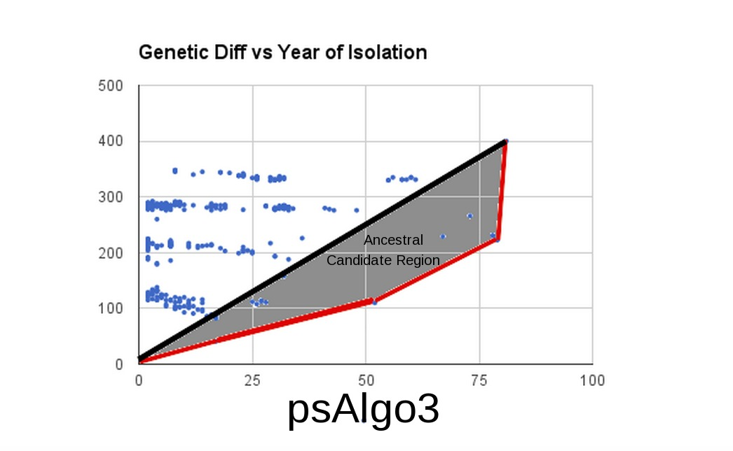

psAlgo3 creates a line from the origin to the rightmost point and uses that as an upper bound. For a lower bound, it uses the results from psAlgo (the red lines) without any truncation of data. It then finds any point in this bound and finds the slope between this point and the origin

Conclusions:

psAlgo and psAlgo2 produce the most accurate results given the sample dataset when compared with accepted mutation rates. psAlgo3 is wildly inaccurate with an average percent error of over 320% over six different segments . psAlgo is slightly more effective than psAlgo2 . Firstly, psAlgo2 has a lower percent error than psAlgo with 83.00% and 101.75 %, respectively. Secondly, psAlgo2 has less variation than psAlgo with standard deviations of percent errors as follows 10.26 and 23.55, respectively. Thirdly, psAlgo2 uses nearly tenfold more points on average (3.83 vs 30.67), making it more reliably consistent and precise. An average of the two is more accurate than psAlgo, but less accurate than psAlgo2 while also having less precision variability. psAlgo2 is the most accurate and precise of the algorithms based on results from testing with a select database.

**Recommendation: psAlgo2**

Segment 1 (Actual = 4.30) Percent Error Points

Mutation rate estimated by psAlgo1: 4.793103448275862 (11.46) 3

Mutation rate estimated by psAlgo2: 4.261380323054332 (00.93) 8

Mutation rate estimated by psAlgo3: 48.44105529785156 (1,026) 63

Mutation rate estimated by psAlgo+: 4.410212926323723 (02.56)

Mutation rate estimated by psAlgo*: 4.393560390356787 (02.09)

Segment 4 (Actual = 5.70)

Mutation rate estimated by psAlgo1: 5.7431749241658245 (00.70) 4

Mutation rate estimated by psAlgo2: 4.982215781846924 (12.63) 111

Mutation rate estimated by psAlgo3: 12.793103218078613 (124.4) 6

Mutation rate estimated by psAlgo+: 5.302497645321122 (07.02)

Mutation rate estimated by psAlgo*: 5.284154124791032 (07.27)

Segment 5 (Actual=3.60)

Mutation rate estimated by psAlgo1: 3.037686809616634 (15.56) 4

Mutation rate estimated by psAlgo2: 2.8585858585858586 (20.60) 9

Mutation rate estimated by psAlgo3: 17.9630184173584 (398.9) 143

Mutation rate estimated by psAlgo+: 2.778843404808317 (23.17)

Mutation rate estimated by psAlgo*: 2.7667617823430186 (23.14)

Segment 6 (Actual=3.20)

Mutation rate estimated by psAlgo1: 3.323890462700661 (03.75) 4

Mutation rate estimated by psAlgo2: 2.8246913580246913 (11.88) 6

Mutation rate estimated by psAlgo3: 3.3333332538604736 (04.07) 1

Mutation rate estimated by psAlgo+: 3.0742909103626763 (04.06)

Mutation rate estimated by psAlgo*: 3.064141750149828 (04.38)

Segment 7 (Actual=1.50)

Mutation rate estimated by psAlgo1: 2.3567567567567567 (57.33) 4

Mutation rate estimated by psAlgo2: 1.50773369199731 (00.66) 30

Mutation rate estimated by psAlgo3: 2.642857074737549 (76.00) 3

Mutation rate estimated by psAlgo+: 1.9322452243770334 (28.70)

Mutation rate estimated by psAlgo*: 1.88503622405631 (25.70)

Segment 8 (Actual=1.60)

Mutation rate estimated by psAlgo1: 2.444444444444444 (52.50) 4

Mutation rate estimated by psAlgo2: 1.9991708126036485 (24.94) 20

Mutation rate estimated by psAlgo3: 6.7317070960998535 (320.6) 9

Mutation rate estimated by psAlgo+: 2.1758739076154807 (36.25)

Mutation rate estimated by psAlgo*: 2.159235311074099 (35.00)

**Abstract Results**

**% Errors**

Summation Mean Stnd Dev

psAlgo : 136.93 22.82 23.55

psAlgo2: 71.640 11.94 9.06

psAlgo3: 1950.0 325.0 342.08

psAlgo+: 101.75 16.96 14.29

psAlgo*: 97.584 16.26 13.49

**Points used**

Summation Mean Stnd Dev

psAlgo : 23 03.83 0.408

psAlgo2: 184 30.67 40.40

psAlgo3: 225 37.50 56.76